**E-RENTAL REAL-ESTATE:**

**WEBSITE**



*Undertaken By:*

**Abdul Moiz**

**Nazirullah**

*Supervised By:*

**Sir Umair Younas**

**DEPARTMENT OF COMPUTER SCIENCE**

**QURTUBA UNIVERSITY**

**DERA ISMAIL KHAN**

**(2020-2024)**



**E-RENTAL REAL-ESTATE:**

A thesis submitted to Qurtuba University of Science & Information Technology (Dera Ismail Khan) as a fulfillment of necessities for the award of degree of Bachelors of Studies in computer science

By

(2020-2024)

**FINAL APPROVAL**

This is certified that we have read the thesis submitted by **Abdul Moiz** & **Nazirullah** with registration number **16621 & 16449**. It is our decision that this thesis of adequate standard to certification its acceptance by the Qurtuba University of Science & Information Technology (Dera Ismail Khan) for the master’s degree in computer science.

1. External Examiner

**Sir**

1. Internal Examiner

**Sir**

1. Supervisor

**Sir Umair Younas**

1. Head of Department

**Sir Dr. Bashir**

**DEDICATION**

I dedicate this thesis to my dearest Parents because without their support and love it could not possible for me to complete it, to my respected Teachers who helped me out to develop the system using the modern techniques.

And I would like to thank my family & friends all those people who motivated & encouraged me during the time of my BS degree.

**Abdul Moiz**

**DECLARATION**

I hereby declare this report not a copied from any source. It is additional declared that check to software and attended report entirely based on personal effort, under the sincere guidance of my supervisor, Teachers & Seniors. If any part of this report is copied out from any source I will stand by the consequences.

Signature of Student

**ACKNOWLEDGMENT**

“And (He desires) that you should complete the prescribed period and that you should glorify Allah for having guided you and that you may give thanks”. (Al-Baqarah 2:185)

I am very grateful to Allah that His blessings and mercies helped me to accomplish this task. I am also very thankful to my parents, siblings and family for their continuous support, prayers, and guidance in the completion of my project and report.

I am immensely grateful to my respected and honorable supervisor “**Sir Umair Yonas**” who proposed this useful and fruitful idea and then helped us under his kind supervision to complete this project.

At the end, I would like to thank my batch mates, my friends and especially my group members for their help, support, motivation, and encouragement throughout this final year.

**Abdul Moiz**

**PROJECT IN BRIEF**

|  |  |
| --- | --- |
| **Project Title** | E-RENTAL REAL-ESTATE: |
| **Organization** | Qurtuba University of Science & Information Technology  (Dera Ismail Khan) |
| **Undertaken by** | Abdul Moiz , Nazirullah |
| **Supervised by** | Sir Umair Younas |
| **Starting Date** | -may-2020 |
| **Ending Date** | -Oct-20224 |
| **Framework Used** | React js , Node js , Express js , MongodDB |
| **Tools Used** | HTML 5, CSS 3, MongoDb |
| **System Used** | Intel Core i5 inside |

**PREFACE**

This report represents description of investigation, improvement, employment & analysis of “E-Rental Real State”. The whole effort is accommodated in following chapters & appendix.

|  |  |
| --- | --- |
| **Chapter One**: | Defines the overview, aims & importance of the system & all the problem statements. |
| **Chapter Two:** | Defines the Existing system and its problems, presenting the new system. |
| **Chapter Three**: | Comprise of complete requirement analysis, scope & objective, functional/Non-functional requirements of the system. This aim of prerequisite analysis is to gather requirement & data from the stakeholders and end users for accomplishment of software. |
| **Chapter Four**: | System Design This part is concerned with the Database design & development. The complete details of all the tables detail discuss in this chapter. |
| **Chapter Five**: | Testing Test planning of the system discuss in this chapter. It deals with testing of the system & accomplish this purpose, designed test plans & test cases to make sure this system is properly working as per standards. |
| **Chapter Six:** | **Conclusion** This Chapter concerns with the testing, Conclusions & Future |

Work. The testing stage represents that all the proposed services & functionalities are properly implemented.

**Chapter Seven: References/ links/ book/website** This part has user guide. All information include that helps the end user to understand & use the application effectively. In this chapter define the user interface is developed very simple & easily interact with.

**ABSTRACT**

Our e-rental system serves as a comprehensive platform where prospective tenants can seamlessly browse through a diverse selection of rental properties, including homes, apartments, and plots in various locations. Using intuitive search filters, users can easily narrow down their options based on specific preferences and requirements. Property owners and managers benefit from a robust suite of tools designed to streamline the listing process, allowing them to present their properties with detailed descriptions and rich multimedia content. Automated scheduling and communication features further enhance tenant inquiries and appointment management, optimizing the rental process for both parties..

**Table of Contents**

**Contents**

Chapter # 1 ...................................................................................................................................... 1

# Introduction ..................................................................................................................................... 1

Introduction ...................................................................................................................... 2

Background ...................................................................................................................... 2

Motivation ........................................................................................................................ 2

Feasibility ......................................................................................................................... 3

Technical Feasibility ................................................................................................. 3

Financial Feasibility .................................................................................................. 3

Resource Feasibility .................................................................................................. 4

Operational Feasibility .............................................................................................. 4

Chapter # 2 ...................................................................................................................................... 2

Requirement Analysis ..................................................................................................................... 2

Introduction ...................................................................................................................... 6

Product Scope ........................................................................................................... 6

Document Convention .................................................................................................... 6

Overall Description .......................................................................................................... 7

Product Perspective ................................................................................................... 7

Product Functionality ................................................................................................ 7

User and Characteristics ........................................................................................... 8

Operating Environment ............................................................................................. 9

Design and implementation constraints .................................................................. 10

User Documentation ............................................................................................... 11 Assumptions and Dependencies ............................................................................. 11

Specific Requirements .................................................................................................... 11

External Interface Requirements............................................................................. 11

Functional Requirement .......................................................................................... 12

Behavioral Requirements ........................................................................................ 12

Chapter # 3 ...................................................................................................................................... 6

System Design ................................................................................................................................ 6

System Design ................................................................................................................ 23

Use Case Diagram ................................................................................................... 23

Class Diagram ......................................................................................................... 25

System Sequence Diagrams .................................................................................... 27

ER Diagram ............................................................................................................ 33

Chapter # 4 .................................................................................................................................... 23

Database Design............................................................................................................................ 23

4.1 Database Design ............................................................................................................. 35

Chapter # 5 .................................................................................................................................... 35

Quality Assurance ......................................................................................................................... 35

Introduction of Testing ................................................................................................... 37

Testing Levels ................................................................................................................ 37

Test Cases ....................................................................................................................... 38

Chapter # 6 .................................................................................................................................... 37

Conclusion & Future Work ........................................................................................................... 37

Conclusion ...................................................................................................................... 41

FuSture Work ................................................................................................................. 41

Chapter # 7 .................................................................................................................................... 41

User Manual .................................................................................................................................. 41

Introduction .................................................................................................................... 43

Hardware/Software Requirements for the System ......................................................... 43

Hardware Interfaces ................................................................................................ 43

Software Interfaces ................................................................................................. 43

Major Features of the System ......................................................................................... 43

Installation Guide ........................................................................................................... 43

Operating Manual ........................................................................................................... 43

Home Page .............................................................................................................. 44

Registration Page .................................................................................................... 44

Login Page .............................................................................................................. 45

Add Foods ............................................................................................................... 46

Show Posted Foods ................................................................................................. 46

References ................................................................................................................................. 47

**List of Tables**

Table 1. 1 Financial Feasibility ....................................................................................................... 3

Table 2. 1 Formatting Conventions................................................................................................. 6

Table 2. 2 Operating Environment .................................................................................................. 9

**List of Figures**

Figure 7. 1 Home Page .................................................................................................................. 44

Figure 7. 2 Database Page ............................................................................................................. 45

Figure 7. 3 Email Collector Page .................................................................................................. 45

Figure 7. 4 Email data collector page ........................................................................................... 46

**Chapter # 1**

**Introduction**

#### Introduction

**Introduction**  
An e-rental system is a platform designed to facilitate the listing and renting of properties such as homes, apartments, and plots. The system allows property owners to list their properties with detailed descriptions and multimedia content, while prospective tenants can browse, search, and book properties online. By automating the listing and booking process, it streamlines operations for both owners and tenants. The system also provides features such as advanced search filters, and automated scheduling of property visits.

**Background**  
This case study addresses the challenges associated with the manual process of property listing and renting. In traditional systems, the following issues are commonly observed:

* Property seekers must manually visit multiple locations and contact owners individually to inquire about properties, which is time-consuming.
* The manual process is inefficient and expensive, especially for owners looking to manage multiple properties.
* There's a higher risk of missed opportunities due to disorganized records and missed communications.

**Motivation**  
The e-rental system aims to provide a seamless experience for both property owners and tenants. By automating the listing and booking processes, property owners can manage their listings more efficiently, while tenants can find and rent properties faster and more conveniently. Features such as email notifications, online booking, make the rental experience more user-friendly. The system is designed to address gaps in the current rental market, ensuring that both tenants and landlords benefit from a smooth, automated process.

**Feasibility**

The feasibility of the "E-Rental System" can be assessed through the following dimensions:

**Technical Feasibility**  
The technical feasibility is based on the resources and technologies required to implement the system. The project will utilize the following technologies:

* **React.js** for building a responsive and interactive frontend.
* **Node.js** and **Express.js** for handling backend operations and APIs.
* **MongoDB** as the database for storing user and property data.
* **Cloudinary** for storing property images.
* **Tailwind CSS** for styling and creating a responsive user interface.

**Financial Feasibility**  
The financial feasibility evaluates the costs involved in acquiring the tools and resources required for the project. The table below summarizes the key financial aspects:

| **Resource Name** | **Price [PKR]** | **Source** |
| --- | --- | --- |
| Visual Studio Code | Free | <https://code.visualstudio.com/> |
| Node.js | Free | https://nodejs.org/en/download/ |
| MongoDB | Free | <https://www.mongodb.com/cloud/atlas> |
| Cloudinary | Free Tier | <https://cloudinary.com/> |
| Laptop | Already owned | Locally available |

**Resource Feasibility**  
All required software and hardware for developing the system are readily available. Development tools like Visual Studio Code, Node.js, and MongoDB offer free plans, making them accessible for project development.

**Operational Feasibility**  
The operational feasibility evaluates the practicality of implementing the project. The system will be tested in a real-world scenario for property listing and renting. The project will be deployed on a live server or tested locally using Postman for backend processes.

* **Location**: Dera Ismail Khan
* **Product Domain**: Service-based property rental platform
* **Localhost Testing**: The system will be tested using Postman and Node.js for backend processing on a localhost environment.

**CHAPTER # 2**

**EXISTING SYSTEM**

**Existing System**

There are various property rental platforms available, such as Airbnb and Zillow, but they often come with complex interfaces and high fees for property owners. These platforms usually require a significant level of technical know-how to fully utilize their features, such as optimizing property listings or managing tenant inquiries. Most platforms charge property owners a percentage of the rental or listing fees, which can add up significantly.  
For instance, Airbnb charges a service fee ranging from 3% to 15% for property owners, making it costly for owners who manage multiple properties. Additionally, many of these systems focus only on short-term rentals, which may not cater to users looking for long-term or flexible rental options.

This makes the process more expensive and limits the flexibility and options for property owners and tenants alike. Despite their convenience, such platforms often lack or proper record-keeping tools for property management.

**Problem Statement**  
Although there are many property rental platforms available, they typically focus on short-term rentals, come with hefty service fees, and may not provide flexible rental durations

Moreover, owners with multiple properties face significant challenges, such as managing numerous listings, tracking tenant inquiries, and scheduling appointments, which can be time-consuming and prone to errors when handled manually. Without a streamlined, cost-effective solution, property owners often find themselves burdened by high fees and complex interfaces.

**Proposed System**  
The e-rental system offers the following key features:

* **Free of cost**: Unlike other platforms that charge a percentage fee, the e-rental system allows property owners to list and manage properties without any service fees.
* **Database records**: All data is stored in a database, allowing for easy management, retrieval, and updating of property information.
* **User-friendly**: The platform is designed with ease of use in mind, allowing even non-technical users to manage properties, respond to inquiries, and track tenant bookings.
* **Efficient sharing**: Scraped or recorded data can easily be shared with others, including property managers or tenants, without complications.

**Chapter # 3 Requirement Analysis**

# Introduction

This chapter provides brief information regarding the E-Rental System project's requirement analysis phase. It covers the product scope, behavior, overall description, functional requirements, and other key aspects of the system.

**Product Scope**

The e-rental platform is designed to streamline the rental process for both tenants and property owners. Users can easily browse rental properties across various locations and filter based on their preferences. The system allows property owners to manage their listings, automate tenant inquiries, schedule viewings, and handle bookings efficiently. The platform will collect and store user and property information securely, maintaining a robust system for both owners and renters to interact seamlessly.

The goal is to create a system that simplifies the entire rental process, offering a flexible and user-friendly interface for property owners and prospective tenants. Owners can manage both short-term and long-term rental options, while tenants can search for homes or plots according to their requirements.

**Document Convention**

This document follows specific conventions throughout. Character sequences, functions, variables, and data types are defined in a standardized manner to ensure clarity and consistency.

**Formatting Convention**

The text in this document follows a consistent formatting style, as shown in Table 2.1:

| **Name** | **Conventions** |
| --- | --- |
| Font | Times New Roman 12pt |
| Heading1 | Bold, 36pt Size |
| Heading2 | Bold, 14pt Size |
| Heading3 | Bold, 12pt Size |
| Line Space | 1.5 Space |
| Justified | Yes |

**Naming Convention**  
The following naming conventions are used throughout the document to ensure easy understanding:

* Terms requiring explanation are defined in “()”.
* Uppercase letters are used to define abbreviations.

**Overall Description**

This section provides an overview of the entire system, including how users will interact with it and the primary processes involved. It details how end users can search for rental properties, list their homes or plots, and manage their rentals efficiently. The system will also highlight any inferred constraints or limitations and present possible solutions at the end.

**Product Perspective**  
The E-Rental system is a web-based platform that allows property owners to list rental properties, while tenants can browse and book these properties easily. The system offers advanced search functionality, ensure a smooth user experience. It simplifies property management by allowing owners to upload rich multimedia content (photos), manage inquiries, and track bookings.

**Product Functionality**  
Product functionality refers to what the e-rental system can do for its users.

* **System**
  + The system will authenticate and validate user inputs (e.g., property details, booking information).
  + It will notify users when specific tasks, such as successful bookings or listing updates, are completed.
* **User**
  + Users will add properties by entering details such as location, price, and amenities.
  + Users will receive alerts for invalid inputs or errors during the listing or booking process.
  + Tenants will receive notifications for successful bookings, or inquiries.

**Operating Environment**

The e-rental system is web-based and requires an internet connection. It supports all major browsers, including Google Chrome, Firefox, Microsoft Edge, and Safari. Users can access the platform via computers, laptops, or smartphones. The system's hardware and software requirements are outlined in Table 2.2:

| **Required** | **Specification** |
| --- | --- |
| Browser | Chrome, Firefox, Edge, Safari, Opera |
| Database | MongoDB |
| Hardware Platform | Computer, laptops, smartphones |
| IDE | Vs Code |
| Operating System | Windows 10 |
| Programming Languages | JavaScript (React.js, Node.js) |

**Design and Implementation Constraints**

This section outlines the constraints encountered during the design and implementation of the e-rental system.

**Domain Constraints**

* We will use Vs code as the IDE.
* The system will be built using JavaScript for both the front-end (React.js) and back-end (Node.js).
* HTML5 and Tailwind CSS , Javascript will be used for client-side rendering and validation.

**Language Constraints**

* JavaScript will be used for server-side development with Node.js, and HTML5/CSS3 will be used for the user interface.

**Implementation Constraints**

* The system will be implemented using Vs code for coding, and tested in postman.

**Time Constraints**

Since this system is a final-year project, it must be completed within a span of one year.

**User Documentation**

A user guide will be provided to each type of user (property owners, tenants, and administrators) based on their role in the system. This guide will explain how to use the system and its key features.

**Assumptions and Dependencies**

* Internet access is required to use the system.
* Users must have a computer, laptop, or smartphone with a compatible web browser.
* Server availability is expected to be 24/7 to ensure smooth operation.

**Specific Requirements**

This section discusses the quality aspects and specific modules of the application in detail.

**External Interface Requirements**

This part describes the system's external requirements, such as input fields and user interaction tools. It also provides an overview of the tools and models used to design these interfaces.

**User Interface**

The system provides a main interface where users can browse properties, input listing details, and manage their accounts. The tenant interface allows users to search properties and book them, while the owner interface facilitates property management.

**Hardware Interface**  
No specialized hardware is required to run the system since it is fully web-based. Users will need access to basic computing devices such as laptops, desktops, or smartphones with internet connectivity.

**Software Interfaces**  
The system software interfaces include:

* **MongoDB** for database management and property storage.
* **Web Browsers** to access the platform online.

**Functional Requirements**  
Functional requirements describe the services that the system will provide to users. These include:

* The system will validate user inputs such as property details and booking information.
* The system will manage property listings and ensure the accuracy of rental data.
* It will maintain a record of all transactions and user activity.

**Chapter # 4**

**Database Design**

*Online Food Order System*

**Data Base Design**

The database design for the e-rental system is structured using **MongoDB**. MongoDB is used to create Models, run queries In this application development, the database stores information related to properties, users, bookings, and other relevant details for efficient functionality. Below is an overview of the database structure.

**Key Tables:**

1. **User Table**: Stores details of users (both property owners and tenants).
   * **user_id**: auto Generated
   * **username**: String, stores the user's name
   * **email**: String, stores the user's email address
   * **password**: String, encrypted password for user authentication
   * **phone_number**: String, stores the user's contact number
   * **role**: Enum (tenant/owner/admin), defines the user type
   * **created_at**: Timestamp, stores the user account creation date
2. **Property Model**: Holds details of properties listed for rent.
   * **property_id**: auto generated id
   * **owner_id**: (references user_id), stores the property owner's user ID
   * **title**: String, title of the property
   * **description**: Text, description of the property
   * **location**: String, stores the address of the property
   * **price**: Decimal, the rental price of the property
   * **images**: Text, stores the image URLs from Cloudinary
   * **created_at**: Timestamp, stores the property listing date
3. **Booking Model**: Stores information about property bookings.
   * **booking_id**: auto generated id
   * **tenant_id**: (references user_id), stores the ID of the tenant making the booking
   * **property_id**: (references property_id), stores the ID of the rented property
   * **booking_date**: Date, stores the date of booking
   * **total_price**: Decimal, stores the total price for the booking period
   * **created_at**: Timestamp, stores the date the booking was made

**Data Flow:**

1. When a **property owner** lists a property, the details (title, location, price, etc.) are stored in the **Property Model**.
2. **Tenants** can browse through available properties and make bookings. Once a booking is made, details are stored in the **Booking Model**.
3. After the booking is complete, The tenant will receive an email.
4. This database design ensures the e-rental system can handle user management, property listings, bookings, with scalable models for future expansions.

13

*Department of Computer Science, QUSIT Dera Ismail Khan*

*Online Food Order System*

14

*Department of Computer Science, QUSIT Dera Ismail Khan*

**Chapter # 6**

**Conclusion & Future Work**

**Conclusion**

The E-Rental system is positioned as a transformative tool in the digital property rental market. With its unique features and functionalities, it addresses specific needs for both property owners and renters. As with any system, its benefits and limitations depend largely on the individual requirements of users. Therefore, before implementation, users should carefully evaluate their needs against the system’s capabilities. The main objective of this system is to automate the rental process, provide ease of property management, and enhance user experience. Additionally, the system’s versatility allows it to cater to various other use cases beyond basic property rentals.

**Future Work**

The following section outlines the features that will be incorporated in future iterations of the E-Rental system:

1. **Website Integration**:
   * Future releases will allow property owners and rental businesses to integrate the E-Rental system with their websites.
   * We plan to launch a dedicated website where other platforms can link to and benefit from our system’s advanced features.
2. **Commercial Availability**:
   * The project will be made commercially available, with the option to sell customized versions of the system to interested property management companies or individuals.
   * Buyers will have the option to fully own and manage the tool, depending on their business model and requirements.
3. **Private Customization**:
   * For organizations or individuals seeking exclusive access to the system, we will offer a private version, tailored specifically to their needs.
   * These custom versions will provide enhanced privacy and personalized features, ensuring the system aligns with their operational goals.
4. **Payment method** :
   * Transaction will be online through this system tenant and owner will be directed.
5. **Automobile** :
   * In future we will add automobiles like Bikes , Cars etc.
6. **Adviser** :
   * In future we are planning to advise the tenant for the plots and automobile which they want to avail.
7. **Feedback and review**:
   * The tenant will add their feedback and review about the particular service which they has been taken.

**Chapter # 7 User Manual**

**Introduction**

This chapter serves as a guide for users to effectively navigate and operate the E-Rental system. It provides a comprehensive overview of the system's features, detailing how users can move around the interface with ease.

**Hardware/Software Requirements for the System**

Specific requirements for any system are referred to as “System Requirements,” which include the necessary software, hardware, operating systems, and other virtual components. The E-Rental system has the following requirements:

**Hardware Interfaces**

The E-Rental system is a web-based application that is compatible with all popular desktop and mobile browsers, such as Google Chrome, Mozilla Firefox, Opera, Safari, and others. The system is developed using the MERN (MongoDB, Express.js, React.js, and Node.js) stack. Users need a stable internet connection to access the system.

**Software Interfaces**

As a web application, the E-Rental system runs on internet browsers. Users can access it from any browser without requiring any additional software installations.

**Installation Guide**

Since the E-Rental system is a web-based application, no installation is necessary. Users simply need to open their preferred browser, enter the system’s URL, and they will have access to the public features of the platform.

**Operating Manual**

This section provides guidance on how to use the various features of the E-Rental system. By following these instructions, users will be able to efficiently interact with the platform and complete desired tasks.

**Home Page**

The home page of the E-Rental system serves as the main entry point, presenting a user-friendly and visually appealing interface. Its design is focused on providing quick access to essential features such as property listings, rental options, and user account management. The homepage ensures that visitors can immediately understand the purpose of the platform and begin navigating with ease.

#### Excel File

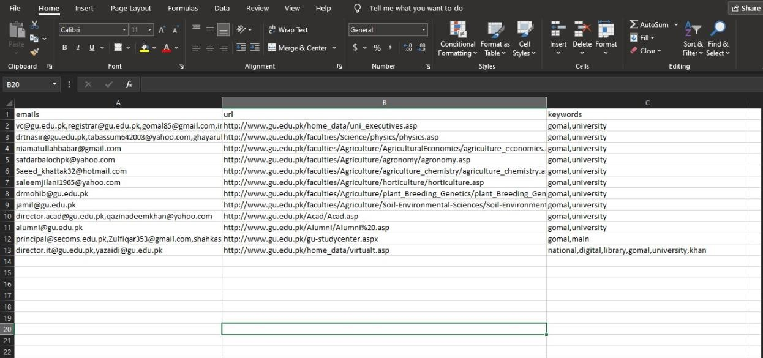

*Excel Page*

#### Email Collector

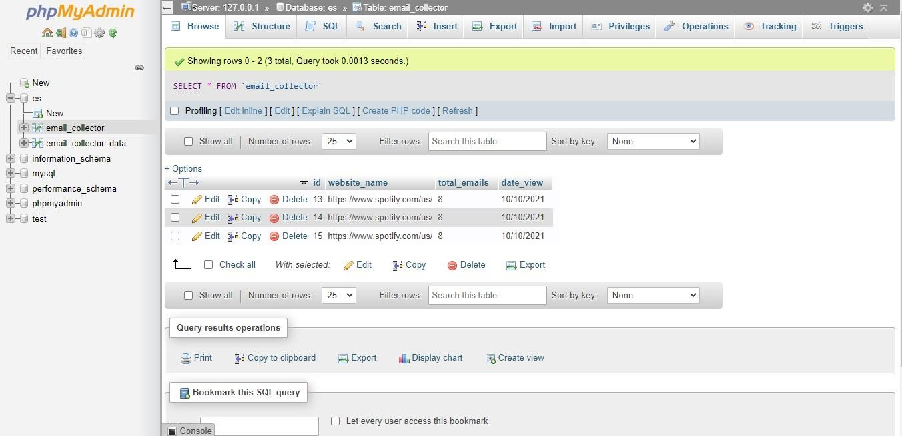

*Email Collector page*

